**DAILY ONLINE ACTIVITIES SUMMARY**

|  |  |  |  |  |  |  |  |  |
| --- | --- | --- | --- | --- | --- | --- | --- | --- |
| **Date:** | **03-07-2020** | | | | | **Name:** | **Anix Jugal D’Cunha** | |
| **Sem & Sec** | **8 sem , A sec** | | | | | **USN:** | **4AL16CS013** | |
| **Online Test Summary** | | | | | | | | |
| **Subject** | | **Not Conducted** | | | | | | |
| **Max. Marks** | | **--** | | **Score** | | | **--** | |
| **Certification Course Summary** | | | | | | | | |
| **Course** | **Easy learning C++ for beginners** | | | | | | | |
| **Certificate Provider** | | | **Udemy** | | **Duration** | | | 5 hours |
| **Coding Challenges** | | | | | | | | |
| **Problem Statement:** Python3 code to find nth ugly number | | | | | | | | |
| **Status: Competed** | | | | | | | | |
| **Uploaded the report in Github** | | | | | **yes** | | | |
| **If yes Repository name** | | | | | **alvas-education-foundation/dcunhaanixjugal** | | | |
| **Uploaded the report in slack** | | | | | **yes** | | | |

Online Test Details: (Attach the snapshot and briefly write the report for the same)

**Not Conducted**

Certification Course Details: (Attach the snapshot and briefly write the report for the same)

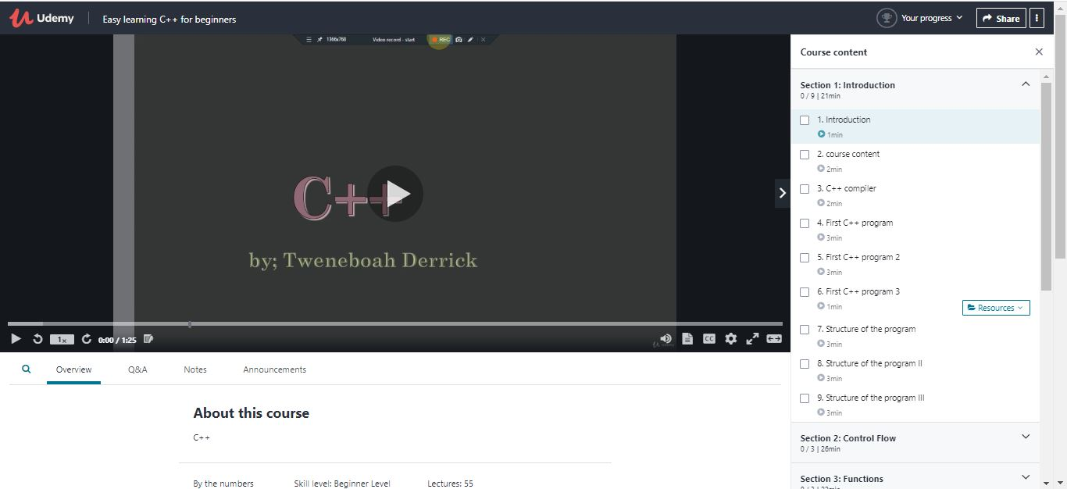

Coding Challenges Details: (Attach the snapshot and briefly write the report for the same)

## Program-> Python3 code to find nth ugly number

|  |
| --- |
|  |

## def maxDivide( a, b ):

## while a % b == 0:

## a = a / b

## return a

## 

## 

## def isUgly( no ):

## no = maxDivide(no, 2)

## no = maxDivide(no, 3)

## no = maxDivide(no, 5)

## return 1 if no == 1 else 0

## 

## 

## def getNthUglyNo( n ):

## i = 1

## count = 1 # ugly number count

## 

## while n > count:

## i += 1

## if isUgly(i):

## count += 1

## return i

## 

## no = getNthUglyNo(150)

## print("150th ugly no. is ", no)